



Fundamentals Of Data Science
Assignment 1 Documentation

SUBMITTED BY
Pawan Gyawali
STUDENT ID: 26008001
SECTION A
THE BRITISH COLLEGE
Program 2 – Arithmetic Operations

Program Description

This program accepts two integers as user input and executes five basic arithmetic operations and shows the results in a formatted table. The program shows the arithmetic operators and the strong input validation in Python.

Purpose: Calculate and show addition, multiplication, division, modulus, and exponentiation of two integers provided by the user.

Important Functionality: The input validation loop with try/except means that only valid integers will be accepted. The output block is presented in a well formatted label block of results.

Functions: Addition (+), Multiplication (×), Division (div, 2 decimals), Modulus (percent), Exponentiation (power of, shown with 2 decimal points).

Error Handling: Non-integer inputs give the user an option to restart the program without a crash.

Testing Screenshot
The screenshot below demonstrates the program running with two sample integer inputs, showing all five arithmetic results.
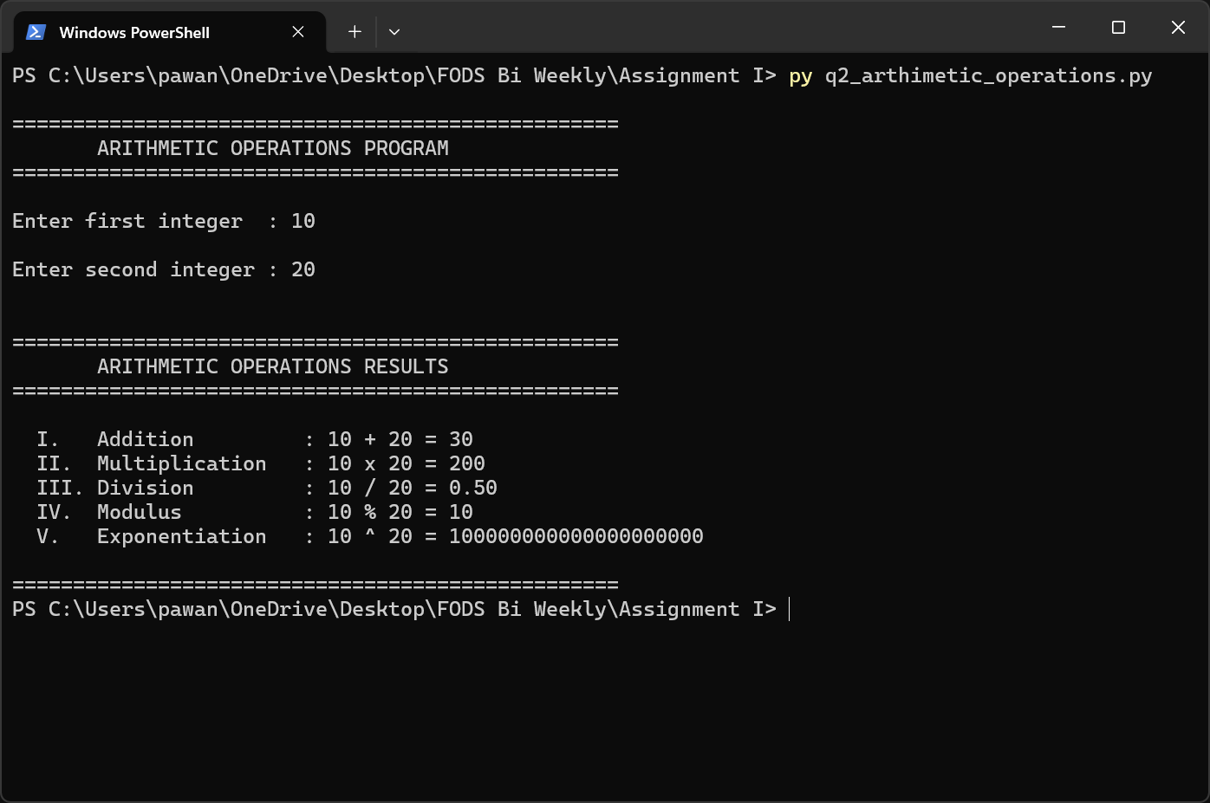
Figure 2.1 – Program 2 executed showing arithmetic results for two user-provided integers.

Program 3 – Number Classification

Program Description
This program categorizes any number typed in by the user in two dimensions (sign positive or negative) and parity (even or odd). It also deals with a range of edge cases such as zero and non-integer (floating-point) values.

Purpose: Find out and show whether a number is Positive Even, Positive Odd, Negative Even, Negative Odd, Zero, or a non-integer.

Key Usability: Takes in floating-point values; Python float.is_integer() finds non-integer values; conditional logic is employed to generate the proper classification.

Edge Cases Managed: Zero (not a positive or negative, is even); non-integer floats (e.g. 3.5 → "Positive (Non-integer Number)"); invalid text input results in graceful exit.

Testing Screenshot
The screenshot below shows the program classifying a sample number, demonstrating the classification output.
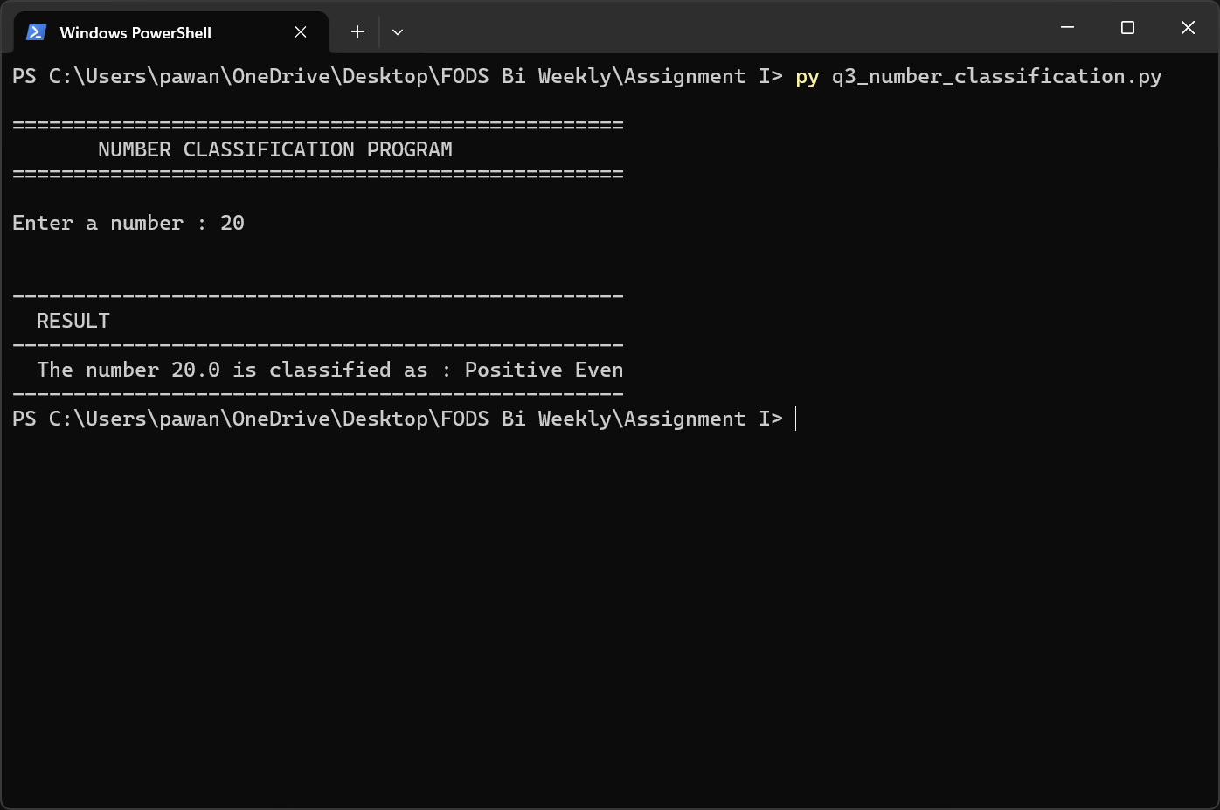
Figure 3.1 – Program 3 executed showing number classification result for user input.

Program 4 – Mathematical Operations

Program Description

This program will accept a single number and will perform five different mathematical operations with the help of the math module of Python. Output is presented in a neat formatted format and special cases (logarithms of non-positive numbers) are gracefully processed.

Purpose: Use the math library in Python to perform more advanced mathematical operations than simple arithmetic.

Important Functionality: Calculates cube, cube root (with sign preservation by using math.copysign), natural logarithm (ln), base-2 logarithm (log 2 ), and sixth power of the input value.

Special Case Handling: When the number is negative or zero, the logarithm values are shown as Undefined (non-positive), rather than raising a math error.

Library: Python built-in math module - math.log, math.log2, math.copysign.

Testing Screenshot
The screenshot below shows the program computing all five operations for a sample numeric input.
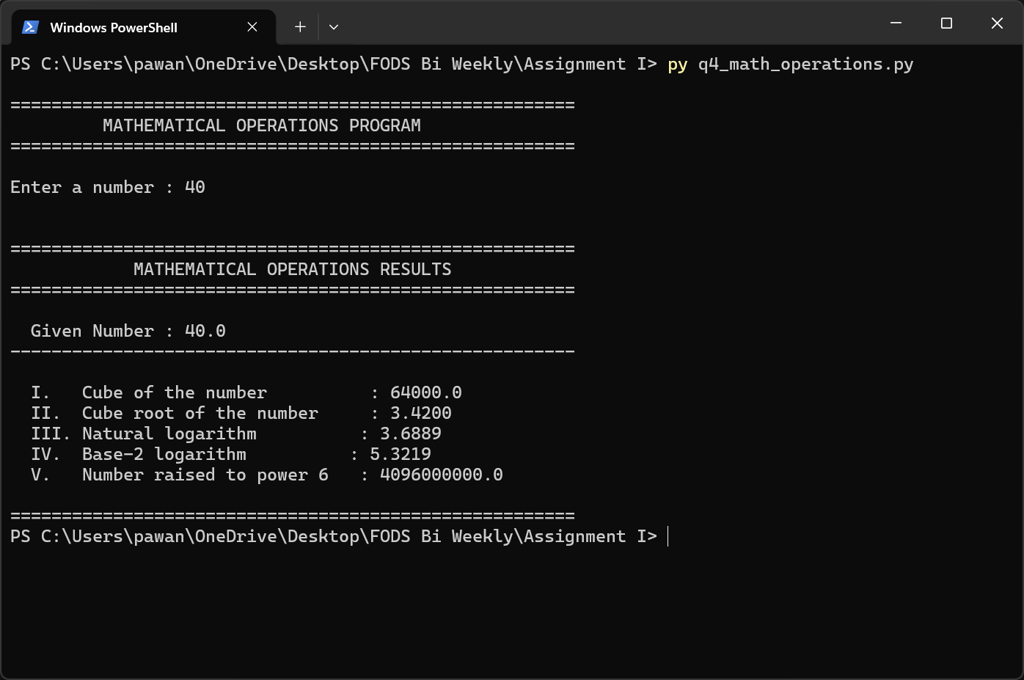
Figure 4.1 – Program 4 executed showing all five mathematical operation results.

Program 5 – Grade Calculation

Program Description
This program marks six subjects and then calculates the total, average, percentage and final grade. It operates on a threshold grading system and confirms every mark to make sure that they are within the acceptable range of 0 to 100.
- Purpose: Automation of calculations of academic outcomes of a student on the basis of the marks in six subjects.
- Important Feature: 6 subject marks are forced; total, average, and percentage are calculated; the appropriate grade is looked up against a threshold table.
- Grading Scale: Distinction (≥85%), First Division (≥70%), Second Division (≥55%), Third Division (≥45%), Fail (<45%).
- Input validation: The marks greater than 0-100 or non-numeric marks will give error message that will require re-entry.

Testing Screenshot
The screenshot below shows the program in action with six subject marks entered, displaying the final grade results.
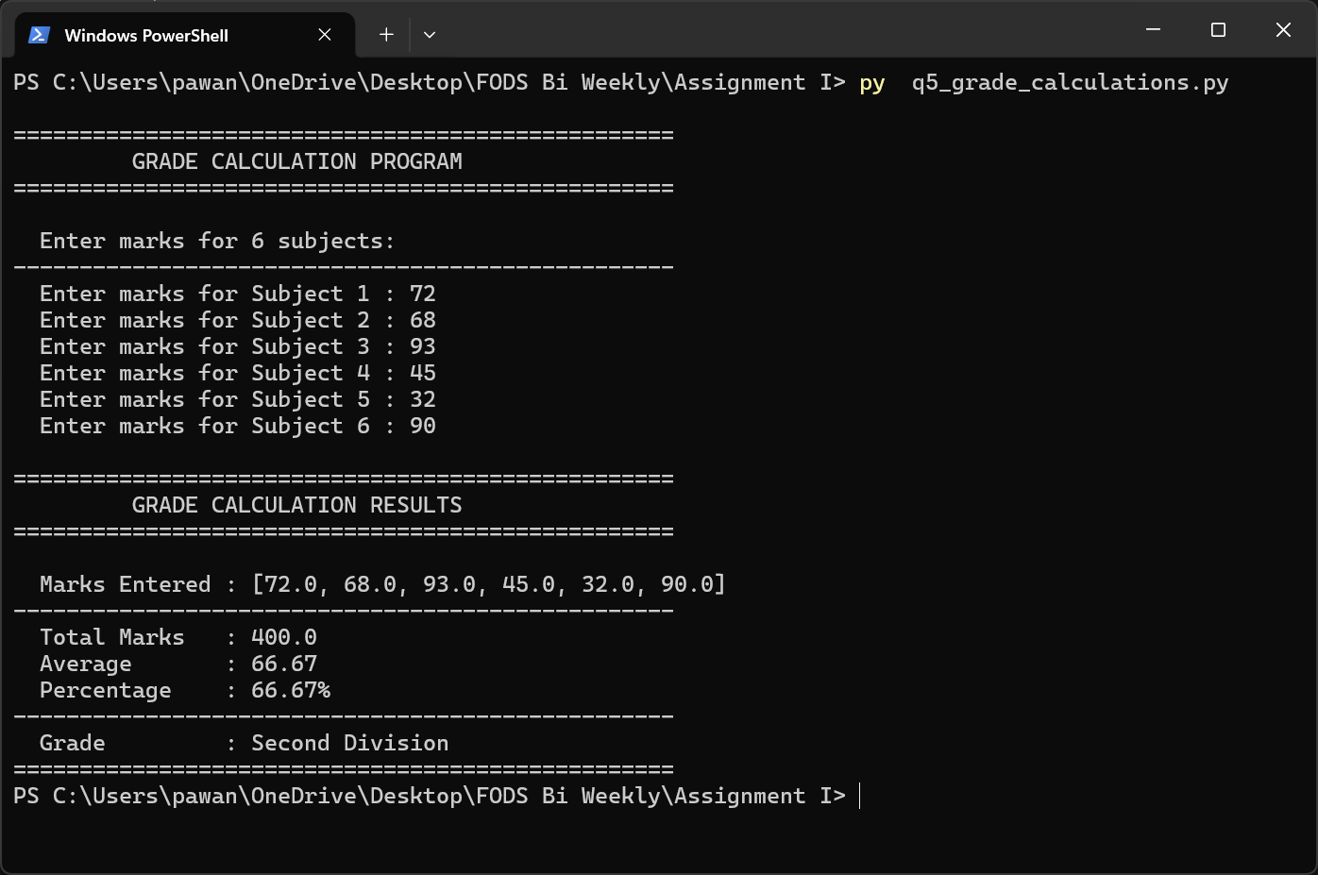
Figure 5.1 – Program 5 executed showing total, average, percentage, and grade results for six subjects.

Program 6 – Prime Numbers Finder

Program Description
This program identifies and presents all prime numbers in a range that is defined by the user. It also gives the total count and the sum of the total count of primes found in the range as well as listing the primes.

Purpose: Find as many prime numbers as you can in a range, and apply mathematical exploration and number theory activities.

Basic Functionality: Defines an optimized is prime function with trial division to a square root of n; collects all primes in the range with list comprehension, and displays the list, the number of primes, and the sum.

Algorithms: Trial division: In each candidate n, test that it is divisible by all numbers between 2 and 1 and all numbers between 2 and 1.

Output: List of all prime numbers, number of primes and the sum of primes.

Testing Screenshot
The screenshot below shows the program finding prime numbers within a sample range.
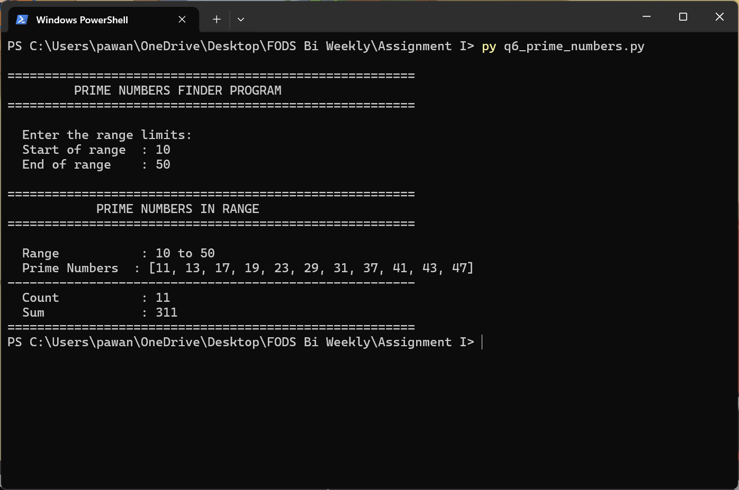
Figure 6.1 – Program 6 executed showing prime numbers, count, and sum for a user-defined range.

Program 7 – Divisibility Finder

Program Description
This program identifies any numbers in a range specified by the user and meeting a particular divisibility criterion: divisible by 9 and not by 6. Outcomes are indicated separately and a total number is given.

Purpose: Show conditional filtering of a list of numbers with Python list comprehensions.

Major Functionality: Takes start and end of range; uses dual-condition filter (num 9 = 0 and num 6 = 0); enumerates every eligible number and gives the number of eligible numbers.

Divisibility Rules: Include numbers which are divisible by 9 (LCM condition); Exclude numbers which are also divisible by 6 (i.e. exclude multiples of LCM(9,6)=18).

Edge Case: In case the condition is not met by any numbers, reports "No numbers in this range found."

Testing Screenshot
The screenshot below shows the program identifying qualifying numbers within sample range.
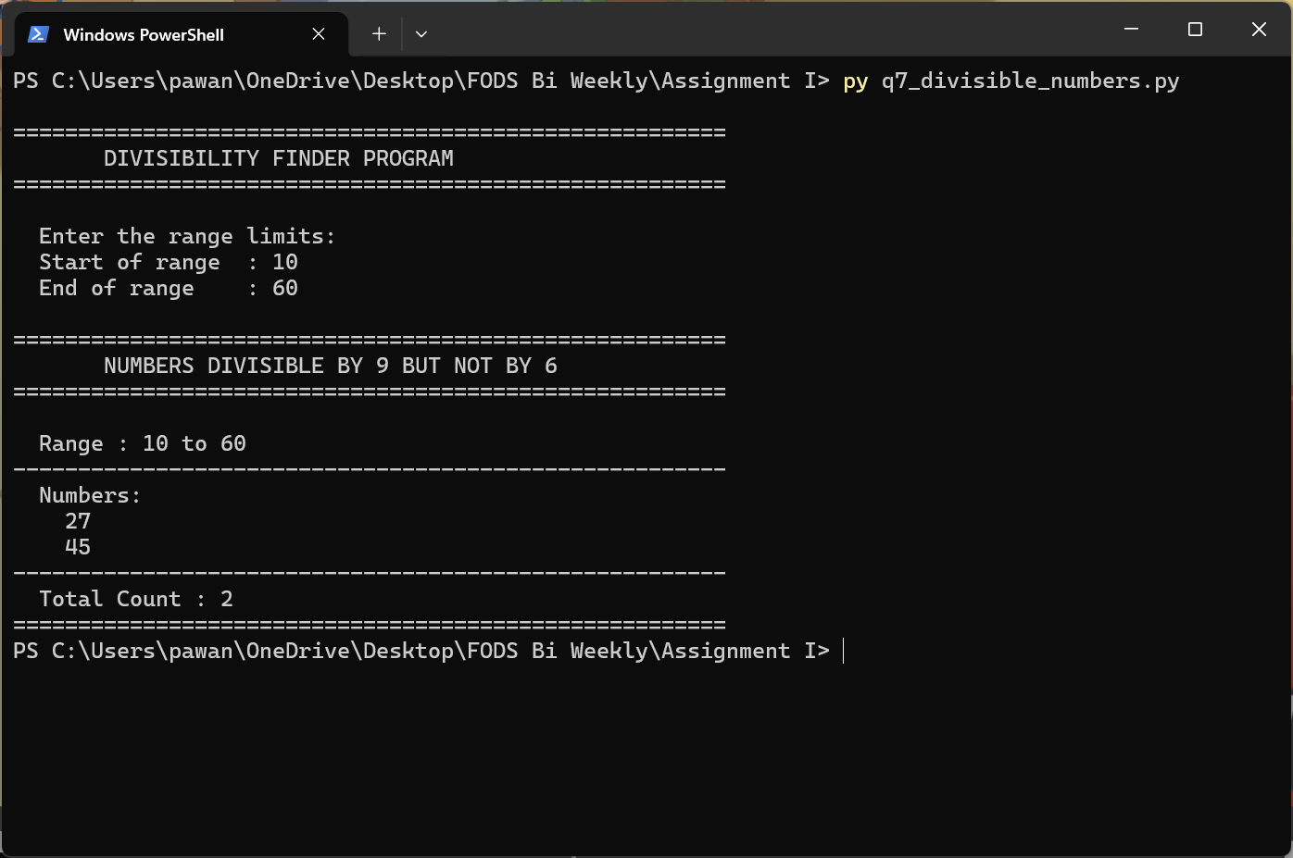
Figure 7.1 – Program 7 executed showing numbers divisible by 9 but not 6 in the given range.

Program 8 – Factorial Calculator

Program Description

This program calculates the factorial of a non-negative number typed in by a user. It recurrently computes the answer and has extensive input validation to deny negative values and non-whole number inputs.

Purpose: Show recursion in Python by calculating n!. A non-negative integer provided by a user is given as (n factorial).

Key Functionality: Recursive compute_factorial(n) procedure; base case: 1 when n=0; input: negatives and non-integers are rejected; output is presented in formatted form.

Algorithm: Recursive definition: 0! = 1; n! = n × (n-1)! for n > 0.

Base Case: The base case is factorial(0) = 1. A descriptive error message is produced by negative or float inputs.

Testing Screenshot
The screenshot below shows the program computing the factorial of a sample positive integer.
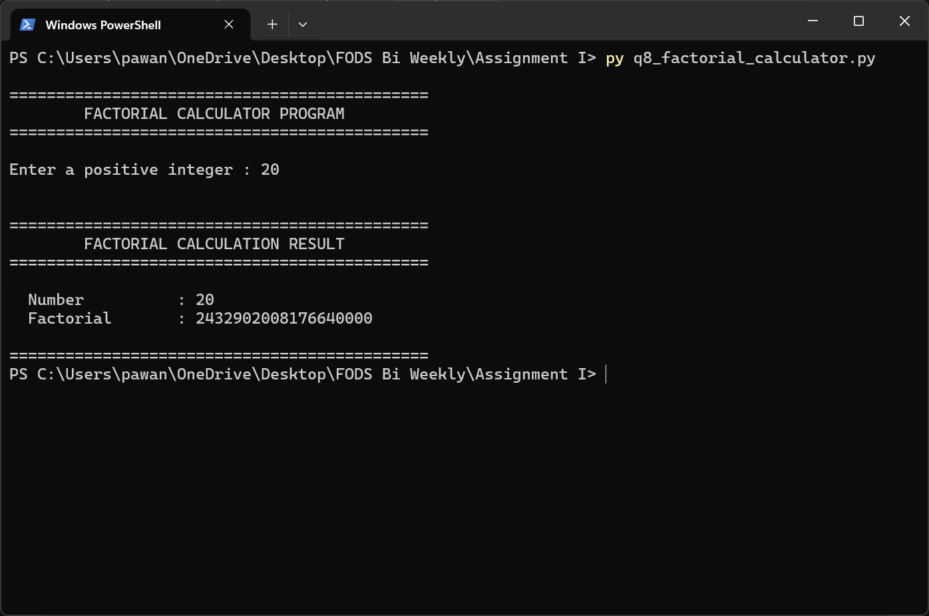
Figure 8.1 – Program 8 executed showing the factorial result for a user-provided positive integer.

Program 9 – Menu-Driven Sum Calculator

Program Description
This interactive, menu-based program keeps running separate positive and negative numbers as they are typed in by the user. This program is in a loop until the user decides to quit the program, providing an example of an object-oriented design, using a NumberAccumulator class.

Purpose: Show an interactive program, written in a menu-driven style, with persistent state over multiple user inputs in one interactive session.

Important Functionality: Menu will give you three choices, (1) Enter a number, (2) View current sums, and (3) Exit. uses a NumberAccumulator class to maintain positive_sum and negative sum separately. Zero is not added to any of the positive or negative totals.

Design Pattern: Object-Oriented: NumberAccumulator class includes state and the add-number method uses the classification logic.

Input Checking: Non-numeric input to menu options or numbers shows an error message and returns to menu.

Testing Screenshots
Two screenshots are provided: one showing numbers being entered (Option 1), and one showing the accumulated sums (Option 2).
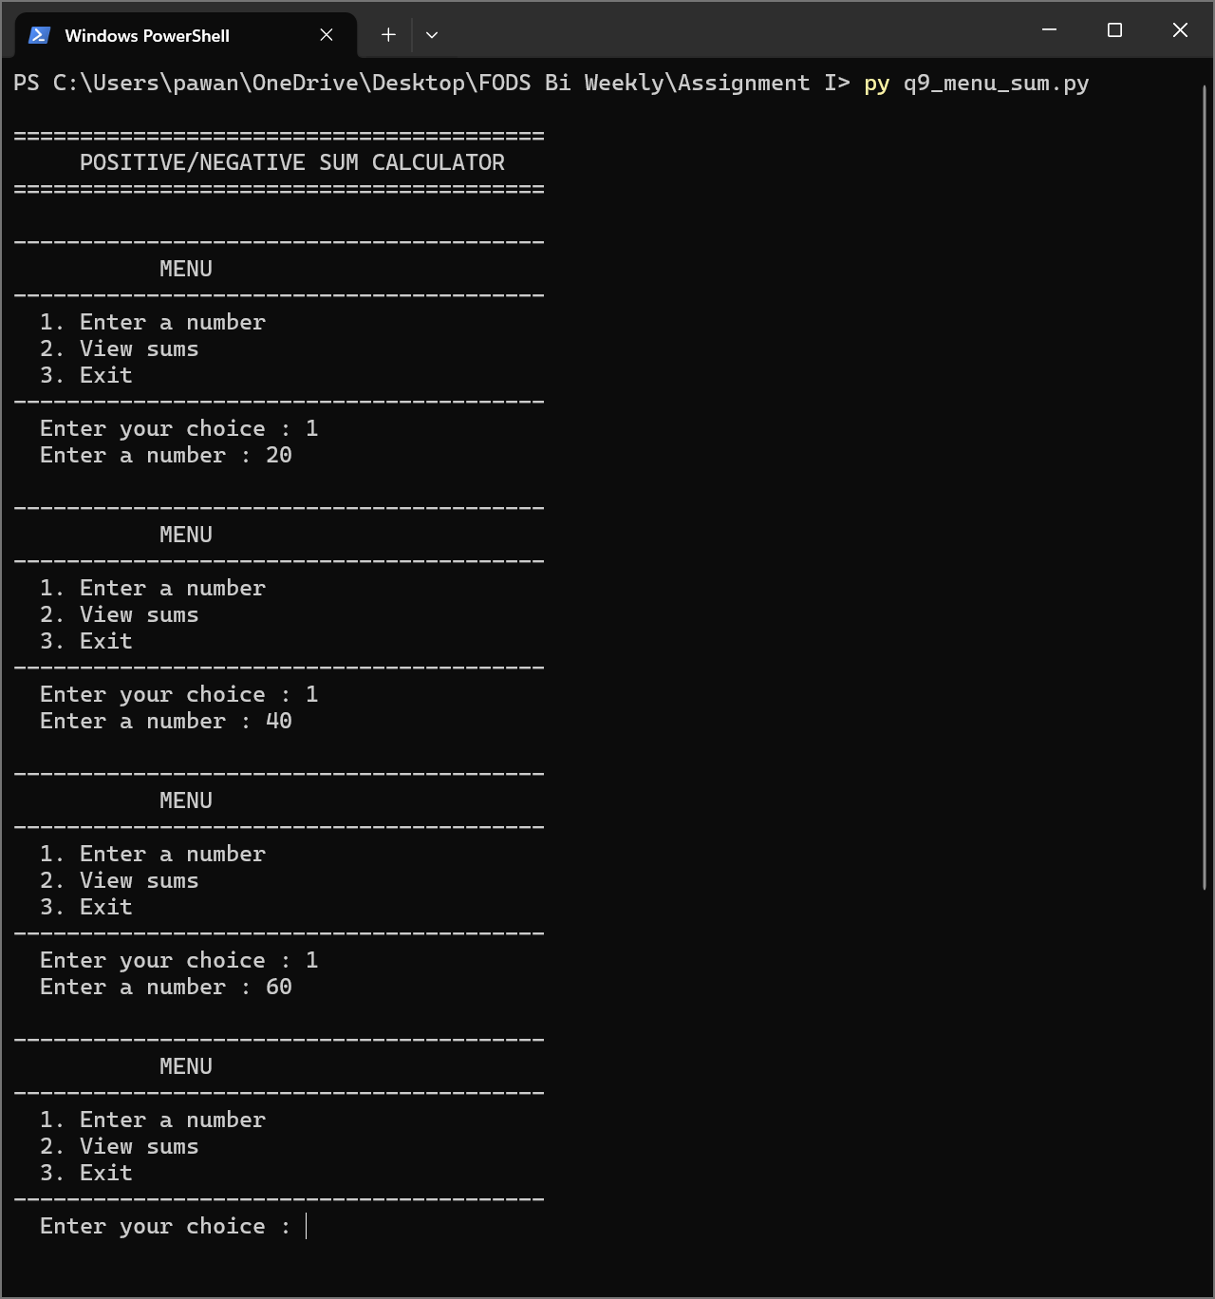
Figure 9.1 – Program 9: Numbers being entered via Menu Option 1, accumulating positive and negative values.
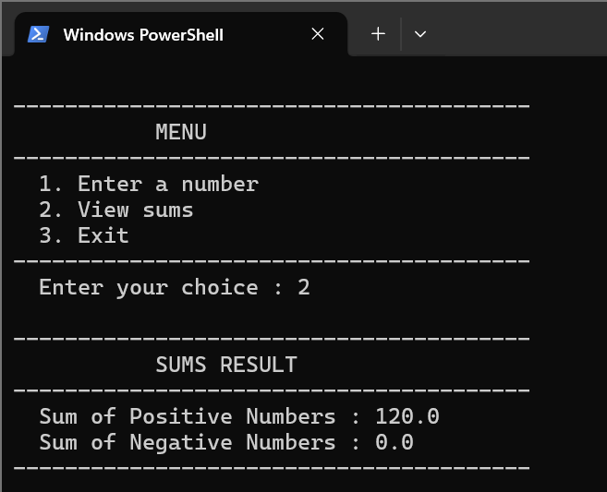
Figure 9.2 – Program 9: Menu Option 2 displaying the current sums of positive and negative numbers.

Program 10 – Number Guessing Game

Program Description

This program uses an interactive game of number guessing whereby the computer will come up with a random number between 1 and 50 and the user will be required to guess the number with just 7 attempts. The directional feedback (too high / too low) is given after every guess the program makes and a score is calculated by the speed with which the player makes the correct guess.

Purpose: Illustrate random number generation, input validation, loop control and game logic in Python.

Important Functions: the secret number is generated using random.randint(1, 50); the game loop provides the player with a maximum of 7 attempts to guess; feedback helps the player make the correct guess; a score is assigned to the player based on correct guesses; the game can be re-played after each game.

Scoring System: Score = (remaining attempts + 1) x 10 points (max 70 points when attempting on the first attempt).

Input Check: Non numeric input and out of range values (not between 1 and 50) are trapped using clear messages and the player retried without failure.

Replay Functionality: Once the game has ended (win or loss), the player is given the option to replay again; a yes or y restart the game recursively.

Testing Screenshot
The screenshot below shows a complete game session including multiple guess attempts with high/low feedback and the final result.
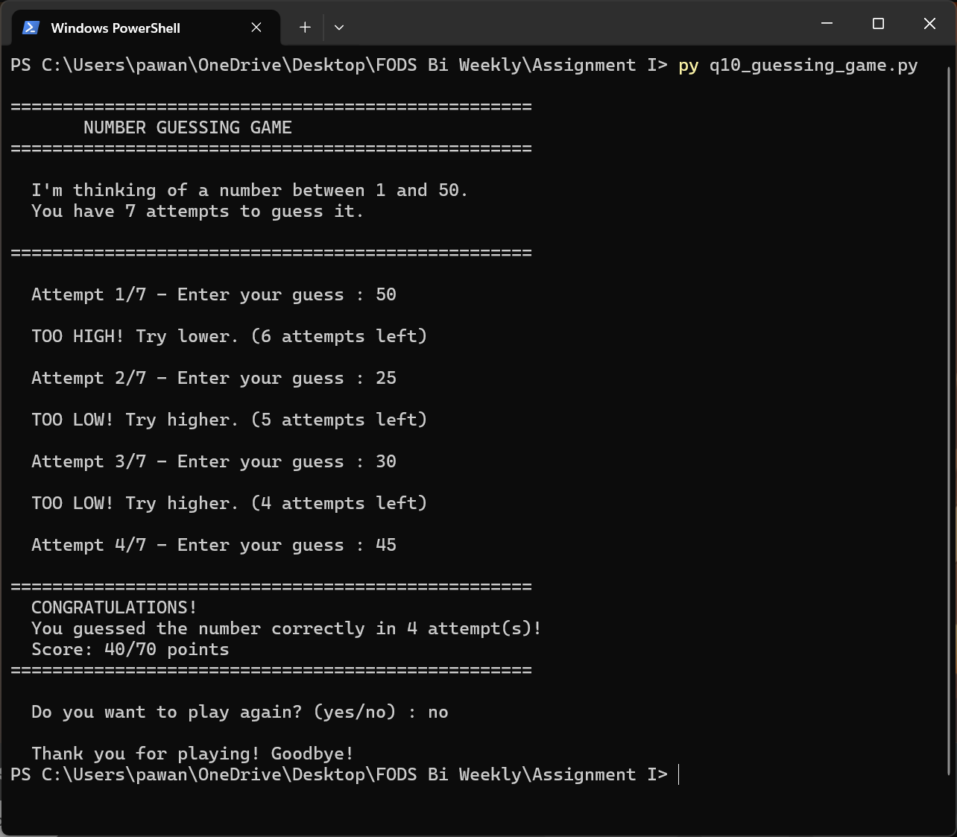
Figure 10.1 – Program 10 executed showing a full game session with guess feedback and final outcome.

